**Software Requirement Specification (SRS)**

Of

**HRMS Module**

**Attendance,Shift Management ,**

**Leave Management**

**&**

**Salary**

For Implementation of

**Campus Management Software**

at

**World Skill Center (WSC)**

**Sustainable Outreach And Universal**

**Leadership (SOUL) Limited**

**Content**

A. Abstract 3

B. Introduction 3

C. Definition, Acronyms and Abbreviations 3

D. Overview of the Document 3

E. Scope of HRMS Module 4

F. List of Screens and their descriptions 4

G. Process Definition and Requirements 6

1. Attendance 6

1.1 Employee Attendance Tool 7

1.2 Attendance 8

1.3 Attendance Request 10

1.4 Upload Attendance 12

1.5 Employee Check In 14

2. Shift Management 16

2.1 Shift Type 17

2.2 Shift Assignment 20

2.3 Shift Request 21

3. Leave Management 23

3.1 Holiday List 24

3.2 Leave Type 26

3.3 Leave Period 30

3.4 Leave Policy 31

3.5 Leave Block List 33

3.6 Leave Policy Assignment 35

3.7 Leave Allocation 37

3.8 Leave Application 39

3.9 Leave Encashment 42

3.10 Compensatory Leave Request 44

4. Salary 47

4.1 Salary Component 47

4.2 Salary Structure 51

4.3 Salary Structure Assignment 55

# Abstract

Software Requirements Gathering is one of the first phases of system development. This phase results in the Software Requirements Specification (SRS) document, which must contain a complete, concise, high-quality description of the system being considered.

# Introduction

The World Skill Center (WSC) is a premier advanced skill training institute established by the Government of Odisha, Skill Development and Technical Education Department, through the Odisha Skill Development Authority (OSDA). The WSC will impart advanced skill training in eight trades from engineering and service sectors. WSC caters primarily to induct the best talent from ITIs and Polytechnics and train them to become globally employable in emerging areas such as "Industry 4.0". WSC is housed in a state-of-the-art, 18-storey, air-conditioned building with nearly half a million square feet of space in the heart of capital city of Bhubaneswar.

With the Implementation of campus management software for WSC the goal is to streamline the operations and functions of the campus by integrating various processes, such as admissions, course registration, academic progress tracking, and financial management, HRMS, Procurement and Inventory management, etc into a unified system. The implementation also aims at providing a user-friendly interface for all stakeholders, making it easier for them to access the necessary information and complete their tasks with ease. The modules to be covered during the implementation of the software includes:

|  |  |
| --- | --- |
| Students Management Modules | Infrastructure Management |
| Academic System | Finance and Accounting System |
| Procurement & Inventory Management | Training and Placement |
| Human Resources Management System | Application Integration |

# Definition, Acronyms and Abbreviations

The following table explains the terms and abbreviations used in the document:

|  |  |
| --- | --- |
| **Abbreviation** | **Description** |
| SRS | Software Requirements Specification |
| HRMS | Human Resource Management System |
| R | Rename - When a field is Renamed |
| N | New - When a New field is Added |
| D | Delete - When an Existing field is Deleted |
| NA | Not Applicable |

# Overview of the Document

This requirement document provides a detailed overview of the functional requirements of a project. It serves as a communication tool between stakeholders, including developers, project managers, and end-users. The purpose of this requirement document is to define and document the project's objectives, scope, and expectations, and to ensure that all stakeholders have a clear understanding of what the project entails.

This document covers all the functional requirements of the sub modules o**f HRMS** including **Attendance,Shift Management,Leave Management and Salary**. This module helps in organizing the overall attendance process of the employee,Shift assignment process of the employee along with the leave monitoring.

# Scope of HRMS Module

* Recruitment process management
* Employee Lifecycle including Employee boarding,promotion,transfer,retirements,separation and re-engagement of employee.
* Staff profile management including Educational qualification,work experience,work history and so on.
* Attendance Management
* Grievance and Disciplinary cases monitoring.
* Performance Management System.
* Leave management
* Shift Management

Following functionalities are covered in this SRS document:

* **Attendance Management**
* **Leave management**
* **Shift management**
* **Salary ** ▪

# List of Screens and their descriptions

The following screens are present in Attendance,Shift and Leave sub-modules :

|  |  |  |
| --- | --- | --- |
| **Sl no** | **Existing Application** **Screen Name** | **Description** |
| Attendance | | |
| 1 | Employee Attendance Tool | Employee Attendance Tool allows you to mark attendance of multiple employees for a particular date. |
| 2 | Attendance | Attendance is a record stating whether an Employee has been present on a particular day or not. |
| 3 | Attendance Request | Using the Attendance Request, employees can submit their attendance request for the days when their attendance wasn't marked due to various reasons such as on-site duty or work from home. |
| 5 | Upload Attendance | This tool helps you to upload bulk attendance from a csv file. |
| 6 | Employee Check In | Employee Check in is used to keep a log of all the check-ins and check-outs of an employee in the organization. |
| Shift Management | | |
| 7 | Shift Type | The Shift Type document allows you to define the different types of Shifts in your Organization and set up auto attendance for the shift. |
| 8 | Shift Request | Shift Request is used by an employee to request for a particular Shift Type. |
| 9 | Shift Assignment | Shift Assignment is created to assign a particular shift type to an employee for a specific period. |
| Leave Management | | |
| 10 | Holiday List | Program Enrollment is the record of enrollment of a student in a given program and chosen courses for a particular Academic Term. |
| 11 | Leave Type | Course Enrollment is the record of enrollment of a student in a given program and chosen courses for a particular Academic Term. |
| 12 | Leave Period | The Student document will hold all the data related to the students. |
| 13 | Leave Policy | An instructor is a teacher, tutor, or a professor who will be responsible for teaching a particular topic or course to the students. |
| 14 | Leave Block List | Student Re registration tool mainly help for enrolling the students into their next semester bulk wise only after the enrollment of first semester. |
| 15 | Leave Policy Assignment | Student Category is based upon the castes of the students such as ST, SC, General, Etc. |
| 16 | Leave Allocation | Student Batch defines every student groups on the basis of their batch. |
| 17 | Leave Application | Fee Category would form all the components for calculation of Fees or creation of Fee Structure. |
| 18 | Leave Encashment | A Fee Structure is a template that can be used while making Fees records or generating them via the Fee Schedule. |
| 19 | Compensatory Leave Request | Fee Schedule would help in defining a time-line for the Fee payment of the students, based on the Student Group. |
| Salary | | |
| 20 | Salary Component | Salaries are paid by organizations to their employees in exchange for the services rendered by them. The different components that make up the Salary Structure are called as Salary Components. |
| 21 | Salary Strutcure | Salary Structure is the details of the salary being offered to an Employee, in terms of the breakup of the different components constituting the compensation. |
| 21 | Salary Strutcure Assignment | Salary Structure Assignment form allows you to assign a particular Salary Structure to the employee. |

# Process Definition and Requirements

## Attendance

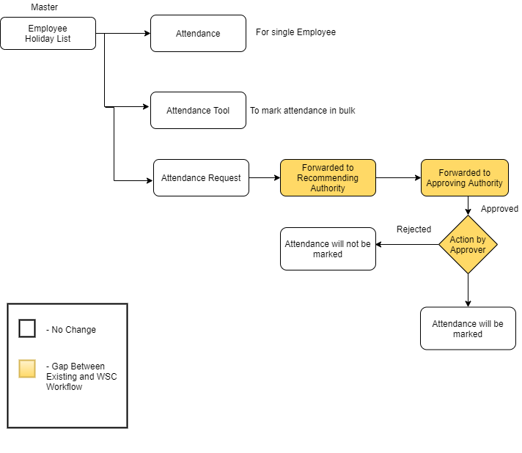

Figure 1 : Attendance Workflow

**Description:**

**Masters**

The Attendance module needs the following master data.

* Employee

**Attendance**

In Application,you can mark and record attendance of an Employee on a daily basis using the Attendance form.

**Attendance Tool**

Employee Attendance Tool allows you to mark attendance of multiple employees for a particular date.

**Attendance Request**

Using the Attendance Request, employees can submit their attendance request for the days when their attendance wasn't marked due to various reasons such as on-site duty or work from home.The attendance request will be approved by the approving authority once forwarded by recommending authority.

### Employee Attendance Tool

**General Description**

The following table describes overall information about this screen:

|  |  |
| --- | --- |
| **Description** | 1. Employee Attendance Tool allows you to mark attendance of multiple employees for a particular date. 2. This tool allows you to add attendance records for multiple employees based on their Department and Branch for a given day quickly. |
| **Navigation** | Home > HRMS >Attendance > Employee Attendance Tool |
| **Pre-requisites** | The system should have records in the following screen   1. Employee 2. Department 3. Branch |
| **Existing Screen Name** | Employee Attendance Tool |
| **New Screen Name** | No change |

**Screenshot**

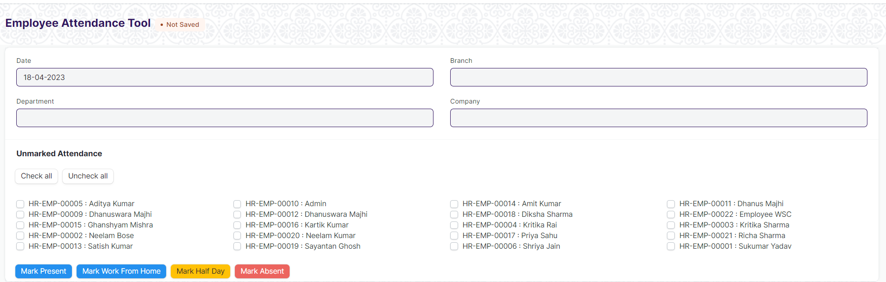

Figure 2: Employee Attendance Tool Screen

**Field List**

The following table describes the UI fields present in this screen :

|  |  |  |  |  |  |  |  |
| --- | --- | --- | --- | --- | --- | --- | --- |
| **ID** | **Label** | **Type** | **Mandatory** | | **Validation / Action** | **Remarks** | **R = Rename**  **N= New**  **D= Delete** |
| 1 | Date | Date |  | | It takes current date |  |  |
| 2 | Department | Link |  | | Link Fields to Master Screen Department |  |  |
| 3 | Branch | Link |  | | Link Fields to Master Screen Branch |  |  |
| 4 | Company | Link |  | | Link Fields to Master Screen Company |  |  |
| 5 | Employees HTML | HTML |  | |  |  |  |
| 6 | Marked Attendance HTML | HTML |  | |  |  |  |
|  | | | | | | | |
| **Action Button** | | | | **Description** | | | |
| Mark Attendance | | | | On clicking mark attendance button , attendance of the selected employee will be taken. | | | |
| Mark Work From Home | | | | On clicking the button, attendance of the selected employee will be marked as Work Form Home | | | |
| Mark Half Day | | | | On Clicking the Button, attendance of the selected employee will be marked as Half Day | | | |
| Mark Absent | | | | On clicking the button , attendance of the selected employee will be marked as absent. | | | |

**User: Roles & Permission**

The following table describes the users and their roles and permissions for the screens :

|  |  |  |  |  |  |  |  |  |  |
| --- | --- | --- | --- | --- | --- | --- | --- | --- | --- |
| **ID** | **Role** | **Select** | **Read** | **Write** | **Create** | **Delete** | **Submit** | **Cancel** | **Amend** |
| 1 | HR Admin/Director Admin | Yes | Yes | Yes | Yes | Yes | NA | NA | NA |
| 2 | HR Manager/CS | No | Yes | Yes | Yes | Yes | NA | NA | NA |
| 3 | HR Assistant | No | Yes | Yes | Yes | No | NA | NA | NA |
| 4 | Employee | No | No | No | No | No | NA | NA | NA |

### Attendance

**General Description**

The following table describes overall information about this screen:

|  |  |
| --- | --- |
| **Description** | 1. Attendance is a record stating whether an Employee has been present on a particular day or not. |
| **Navigation** | Home > HRMS> Attendance> Attendance |
| **Pre-requisites** | The system should have records in the following screen   1. Employee 2. Shift Type |
| **Existing Screen Name** | Attendance |
| **New Screen Name** | No change |

**Screenshot**

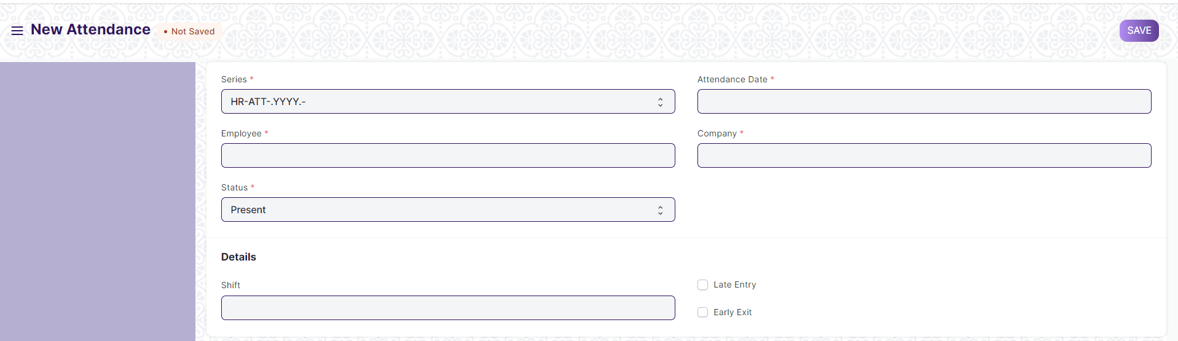

Figure 3: Attendance Screen

**Field List**

The following table describes the UI fields present in this screen :

|  |  |  |  |  |  |  |
| --- | --- | --- | --- | --- | --- | --- |
| **ID** | **Label** | **Type** | **Mandatory** | **Validation / Action** | **Remarks** | **R = Rename**  **N= New**  **D= Delete** |
| 1 | Employee | Link | Yes | Link Fields to the Master Screen Employee |  |  |
| 2 | Employee Name | Text |  |  | Auto Fetched when employee is selected |  |
| 3 | Working Hours | Number |  |  |  |  |
| 4 | Status | Drop down | Yes | Options :  Absent  Present  On Leave  Half Day  Work From Home |  |  |
| 5 | Leave Type | Link |  |  | On selection of Half Day / On Leave this field will show |  |
| 6 | Leave Application | Link |  | Link Field to Leave Application Screen. | Will be fetched when an employee is on leave . |  |
| 7 | Attendance Date | Date | Yes | User will select date | By default current date will be there |  |
| 8 | Company | Link | Yes | Link Fields to Master Screen Company |  |  |
| 9 | Department | Link |  | Link Fields to Master screen Department | Auto fetched when employee is selected |  |
| 10 | Attendance Request | Link |  | Link Fields to Attendance Request Screen | Will be fetched when giving attendance to a request. |  |
| 11 | Shift | Link |  | Link Fields to Master Screen Shift Type | User will select the shift |  |
| 12 | In Time | Date time |  |  |  |  |
| 13 | Out Time | Date time |  |  |  |  |
| 14 | Late Entry | Checkbox |  | If enabled , then late entry will be marked |  |  |
| 15 | Early Exit | Checkbox |  | If enabled , then early exit will be marked. |  |  |

**User: Roles & Permission**

The following table describes the users and their roles and permissions for the screens :

|  |  |  |  |  |  |  |  |  |  |
| --- | --- | --- | --- | --- | --- | --- | --- | --- | --- |
| **ID** | **Role** | **Select** | **Read** | **Write** | **Create** | **Delete** | **Submit** | **Cancel** | **Amend** |
| 1 | HR Admin/Director Admin | Yes | Yes | Yes | Yes | Yes | Yes | Yes | Yes |
| 2 | HR Manager/CS | No | Yes | Yes | Yes | Yes | Yes | Yes | Yes |
| 3 | HR Assistant | No | Yes | Yes | Yes | No | Yes | No | No |
| 4 | Employee | No | Yes | No | No | No | No | No | No |

### Attendance Request

**General Description**

The following table describes overall information about this screen:

|  |  |
| --- | --- |
| **Description** | 1. Using the Attendance Request, employees can submit their attendance request for the days when their attendance wasn't marked due to various reasons such as on-site duty or work from home. |
| **Navigation** | Home > HRMS > Attendance > Attendance Request |
| **Pre-requisites** | The system should have records in the following screen   1. Employee |
| **Existing Screen Name** | Attendance Request |
| **New Screen Name** | No change |

**Screenshot**

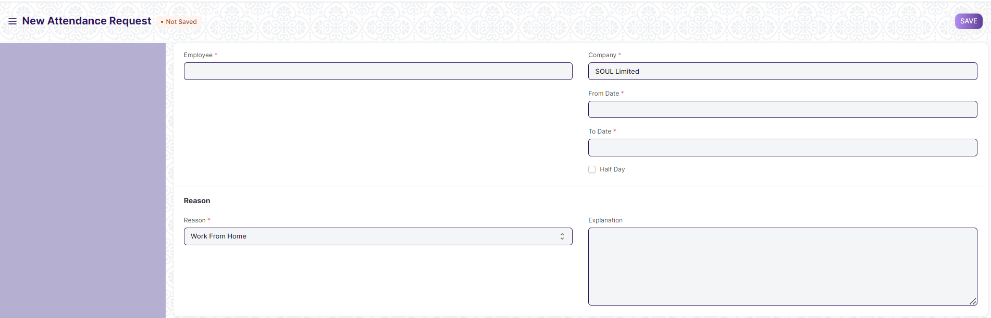

Figure 4: Attendance Request Screen

**Field List**

The following table describes the UI fields present in this screen :

|  |  |  |  |  |  |  |
| --- | --- | --- | --- | --- | --- | --- |
| **ID** | **Label** | **Type** | **Mandatory** | **Validation / Action** | **Remarks** | **R = Rename**  **N= New**  **D= Delete** |
| 1 | Employee | Link | Yes | Link Fields to Employee Screen |  |  |
| 2 | Employee Name | Text |  |  | Auto fetched on selection of employee |  |
| 3 | Department | Link |  | Link Fields to Master Screen Department | Auto Fetched on Selection of employee |  |
| 4 | Company | Link | Yes | Link Fields to Master screen Company | Auto Fetched on selection of employee |  |
| 5 | From Date | Date | Yes | User will input the date | Present and Future Date attendance request can be submitted |  |
| 6 | To Date | Date | Yes | User will input the date |  |  |
| 7 | Half Day | Checkbox |  | If checked then half day will be considered. |  |  |
| 7 | Is Late Entry | Checkbox |  |  |  | N |
| 8 | Late Entry Time | Time |  | If “Is Late Entry” is checked , then user has to input the late entry time. |  | N |
| 9 | Is Early Exist | Checkbox |  |  |  | N |
| 10 | Early Exist Time | Time |  | If “Is Early Exit” is checked , then user has to input the Early Exit time. |  | N |
| 11 | Half Day Date | Date |  | User will give input the date of half day. |  |  |
| 12 | Reason | Drop down | Yes | Options :  On duty  Work From Home |  |  |
| 13 | Explanation | Text |  |  |  |  |

**Note** :

**1.Validation**

1. Employee should be able to request attendance for late entry and early exit.
2. Employee should be able to request attendance for present and future date “On Duty”.
3. Attendance should be marked on the date for which attendance is requested.

**User: Roles & Permission**

The following table describes the users and their roles and permissions for the screens :

|  |  |  |  |  |  |  |  |  |  |
| --- | --- | --- | --- | --- | --- | --- | --- | --- | --- |
| **ID** | **Role** | **Select** | **Read** | **Write** | **Create** | **Delete** | **Submit** | **Cancel** | **Amend** |
| 1 | HR Admin/Director Admin | Yes | Yes | Yes | Yes | Yes | Yes | Yes | Yes |
| 2 | HR Manager/CS | No | Yes | Yes | Yes | Yes | Yes | Yes | Yes |
| 3 | HR Assistant | No | Yes | Yes | Yes | No | Yes | No | No |
| 4 | Employee | No | Yes | Yes | Yes | Yes | No | No | No |

### Upload Attendance

**General Description**

The following table describes overall information about this screen:

|  |  |
| --- | --- |
| **Description** | 1. This tool helps you to upload bulk attendance from a csv file. |
| **Navigation** | Home > HRMS> Attendance > Upload Attendance |
| **Pre-requisites** | The system should have records in the following screen   1. Employee |
| **Existing Screen Name** | Upload Attendance |
| **New Screen Name** | No change |

**Screenshot**

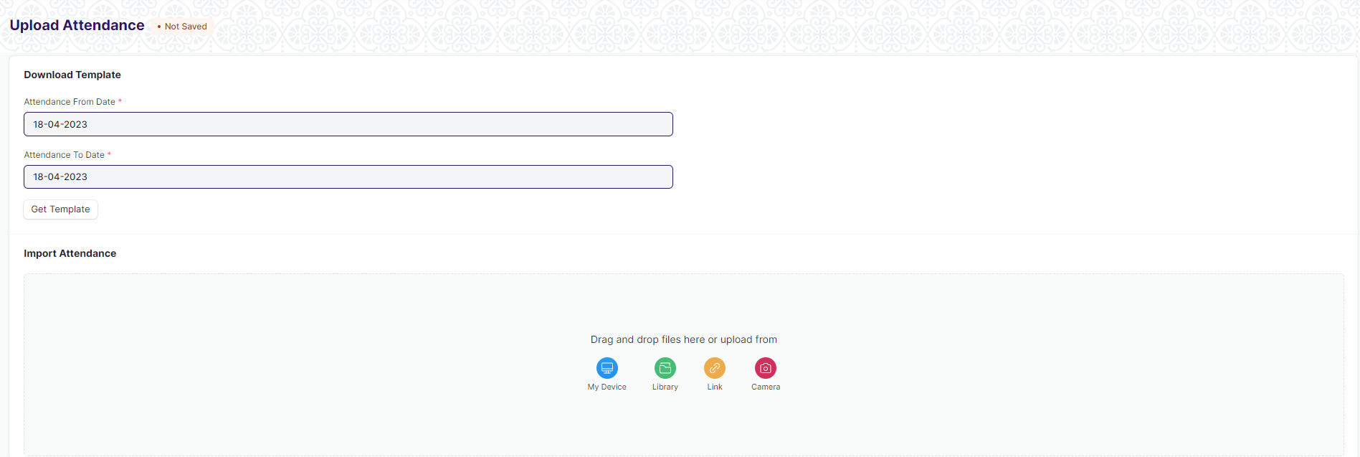

Figure 5: Upload Attendance Screen

**Field List**

The following table describes the UI fields present in this screen :

|  |  |  |  |  |  |  |
| --- | --- | --- | --- | --- | --- | --- |
| **ID** | **Label** | **Type** | **Mandatory** | **Validation / Action** | **Remarks** | **R= Rename**  **N= New**  **D= Delete** |
| 1 | Attendance From Date | Date | Yes |  | User will input the date |  |
| 2 | Attendance To Date | Date | Yes |  | User will input the date |  |
| 3 | Get Template | Button |  |  | On clicking the button, a csv file with employee details will be downloaded |  |
| 4 | Upload HTML | HTML |  |  | After changing the Status (Present/Absent ) in the csv file upload the csv . |  |
| 5 | Import Log | HTML |  |  |  |  |

**User: Roles & Permission**

The following table describes the users and their roles and permissions for the screens :

|  |  |  |  |  |  |  |  |
| --- | --- | --- | --- | --- | --- | --- | --- |
| **ID** | **Role** | **Select** | **Read** | **Write** | **Create** | **Delete** | **Submit** |
| 1 | HR Admin/Director Admin | Yes | Yes | Yes | Yes | Yes | NA |
| 2 | HR Manager /CS | Yes | Yes | Yes | Yes | Yes | NA |
| 3 | HR Assistant | No | Yes | No | No | No | NA |
| 4 | Employee | No | Yes | No | No | No | NA |

### Employee Check In

**General Description**

The following table describe overall information about this screen:

|  |  |
| --- | --- |
| **Description** | 1. Employee Check in is used to keep a log of all the check-ins and check-outs of an employee in the organization. 2. Most organizations use this for attendance, shift management, and working hours calculations. |
| **Navigation** | Home > HRMS> Attendance > Employee Check in |
| **Pre-requisites** | The system should have records in the following screen   1. Employee 2. Shift Type 3. Shift Assignment |
| **Existing Screen Name** | Employee Check in |
| **New Screen Name** | No change |

**Screenshot**

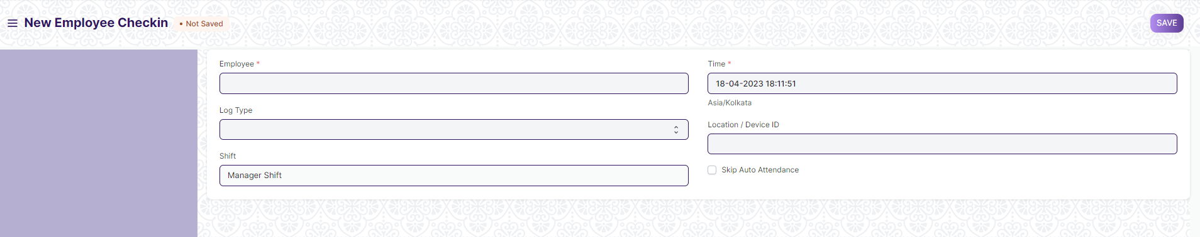

Figure 6 : Employee Check in Screen

**Field List**

The following table describes the UI fields present in this screen :

|  |  |  |  |  |  |  |
| --- | --- | --- | --- | --- | --- | --- |
| **ID** | **Label** | **Type** | **Mandatory** | **Validation / Action** | **Remarks** | **R= Rename**  **N= New**  **D= Delete** |
| 1 | Employee | Link | Yes | Link Fields to Employee Screen |  |  |
| 2 | Employee Name | Text |  |  |  |  |
| 3 | Log Type | Drop down |  | Options :  IN  OUT |  |  |
| 4 | Shift | Link |  | Link Fields to Master screen Shift Type |  |  |
| 5 | Time | Datetime | Yes | User will give the time | By default takes the current time |  |
| 6 | Location/Device ID | Text |  |  |  |  |
| 7 | Skip Auto Attendance | Checkbox |  | If checked, then record will be skipped while marking attendance. |  |  |
| 8 | Attendance Marked | Link |  |  |  |  |
| 9 | Shift Start | Datetime |  |  |  |  |
| 10 | Shift End | Datetime |  |  |  |  |
| 11 | Shift Actual Start | Datetime |  |  |  |  |
| 12 | Shift Actual End | Datetime |  |  |  |  |

**User: Roles & Permission**

The following table describes the users and their roles and permissions for the screens :

|  |  |  |  |  |  |  |  |  |  |
| --- | --- | --- | --- | --- | --- | --- | --- | --- | --- |
| **ID** | **Role** | **Select** | **Read** | **Write** | **Create** | **Delete** | **Submit** | **Cancel** | **Amend** |
| 1 | HR Admin/Director Admin | Yes | Yes | Yes | Yes | Yes | NA | NA | NA |
| 2 | HR Manager/CS | No | Yes | Yes | Yes | Yes | NA | NA | NA |
| 3 | HR Assistant | No | Yes | Yes | Yes | Yes | NA | NA | NA |
| 4 | Employee | No | Yes | Yes | Yes | Yes | NA | NA | NA |

## Shift Management

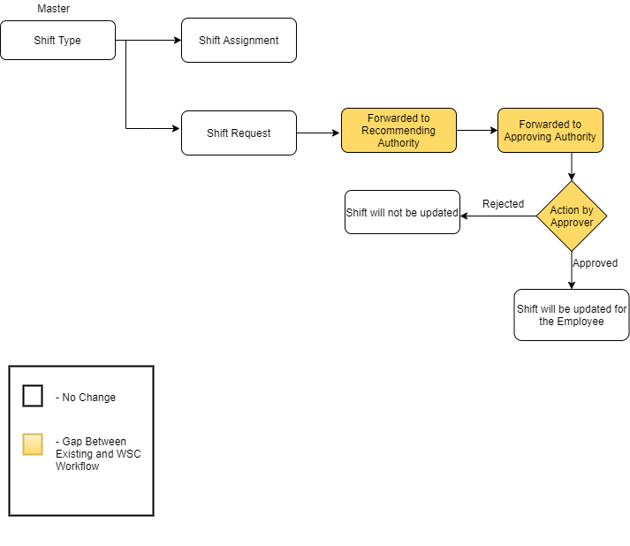

Figure 7 : Shift Management Workflow

**Description:**

**Masters**

The Shift Management module needs the following master data.

* Shift Type

**Shift Assignment**

Shift Assignment is created to assign a particular shift type to an employee for a specific period.

**Shift Request**

Shift Request is used by an employee to request for a particular Shift Type.It will be approved by approving authority after forwarded by recommending authority.

**Masters**

### Shift Type

**General Description**

The Following table describe overall information about this screen:

|  |  |  |
| --- | --- | --- |
| **Description** | | 1. The Shift Type document allows you to define the different types of Shifts in your Organization and set up auto attendance for the shift. 2. Auto attendance marks attendance based on [Employee Checkin](https://docs.erpnext.com/docs/v14/user/manual/en/human-resources/employee_checkin) records for employees assigned to a shift. |
| **Navigation** | Home > HRMS> Shift Management > Shift Type | |
| **Pre-requisites** | The system should have records in the following screen:   1. Holiday List | |
| **Existing Screen Name** | Shift Type | |
| **New Screen Name** | No change | |

**Screenshot**

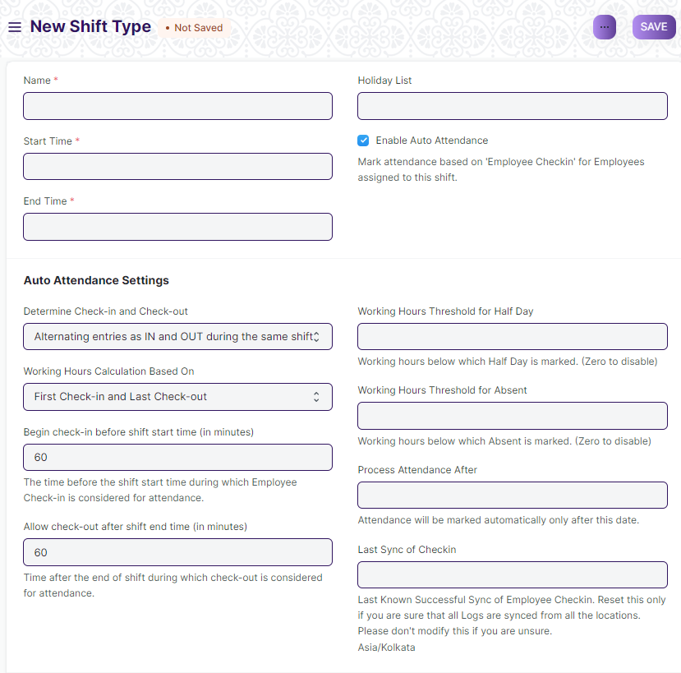

Figure 8: Shift Type Screen

**Field List**

The following table describes the UI fields present in this screen :

|  |  |  |  |  |  |  |
| --- | --- | --- | --- | --- | --- | --- |
| **ID** | **Label** | **Type** | **Mandatory** | **Validation/ Action** | **Remarks** | **R = Rename**  **N= New**  **D= Delete** |
| 1 | Start Time | Time | Yes |  |  |  |
| 2 | End Time | Time | Yes |  |  |  |
| 3 | Holiday List | Link |  | Link to Master screen “Holiday List” |  |  |
| 4 | Enable Auto Attendance | Checkbox |  | If checked,this option enable marking attendance for the employees assigned to this shift based on their Employee Check-in records. |  |  |
| 5 | Determine Check-in and Check-out | Dropdown |  | **Options:**   1. Alternating entries as IN and OUT during the same shift 2. Strictly based on Log Type in Employee Check-in |  |  |
| 6 | Working Hours Calculation Based On | Dropdown |  | **Options:**   1. First Check-in and Last Check-out 2. Every Valid Check-in and Check-out |  |  |
| 7 | Begin check-in before shift start time (in minutes) | Number |  |  |  |  |
| 8 | Allow check-out after shift end time (in minutes) | Number |  |  |  |  |
| 9 | Working Hours Threshold for Half Day | Float |  |  |  |  |
| 10 | Working Hours Threshold for Absent | Float |  |  |  |  |
| 11 | Process Attendance After | Date |  |  |  |  |
| 12 | Last Sync of Checkin | Datetime |  |  |  |  |
| 13 | Enable Entry Grace Period | Checkbox |  | If checked below field will appear. |  |  |
| 14 | Late Entry Grace Period | Number |  | If “Enable Entry Grace Period”is checked,this field will appear. |  |  |
| 15 | Enable Exit Grace Period | Checkbox |  | If checked below field will appear. |  |  |
| 16 | Early Exit Grace Period | Number |  | If “Enable Exit Grace Period”is checked,this field will appear. |  |  |
|  | Mark Attendance | Button |  | This button will appear once the form is submitted and user can mark the attendance of the employees of respective shift type and based on the Employee Checkin. |  |  |

**User: Roles & Permission**

The following table describes the users and their roles and permissions for the screens :

|  |  |  |  |  |  |  |  |  |  |
| --- | --- | --- | --- | --- | --- | --- | --- | --- | --- |
| **ID** | **Role** | **Select** | **Read** | **Write** | **Create** | **Delete** | **Submit** | **Cancel** | **Amend** |
| 1 | HR Admin/Director Admin | Yes | Yes | Yes | Yes | Yes | NA | NA | NA |
| 2 | HR Manager/CS | No | Yes | Yes | Yes | No | NA | NA | NA |
| 3 | HR Assistant | No | Yes | No | No | No | NA | NA | NA |
| 4 | Employee | No | Yes | No | No | No | NA | NA | NA |

**Transactional Screen**

### Shift Assignment

**General Description**

The following table describes overall information about this screen:

|  |  |
| --- | --- |
| **Description** | 1. A Shift Assignment is created to assign a particular shift type to an employee for a specific period. |
| **Navigation** | Home > HRMS > Shift Management > Shift Assignment |
| **Pre-requisites** | The system should have records in the following screen:   1. Employee 2. Shift Type |
| **Existing Screen Name** | Shift Assignment |
| **New Screen Name** | No change |

**Screenshot**

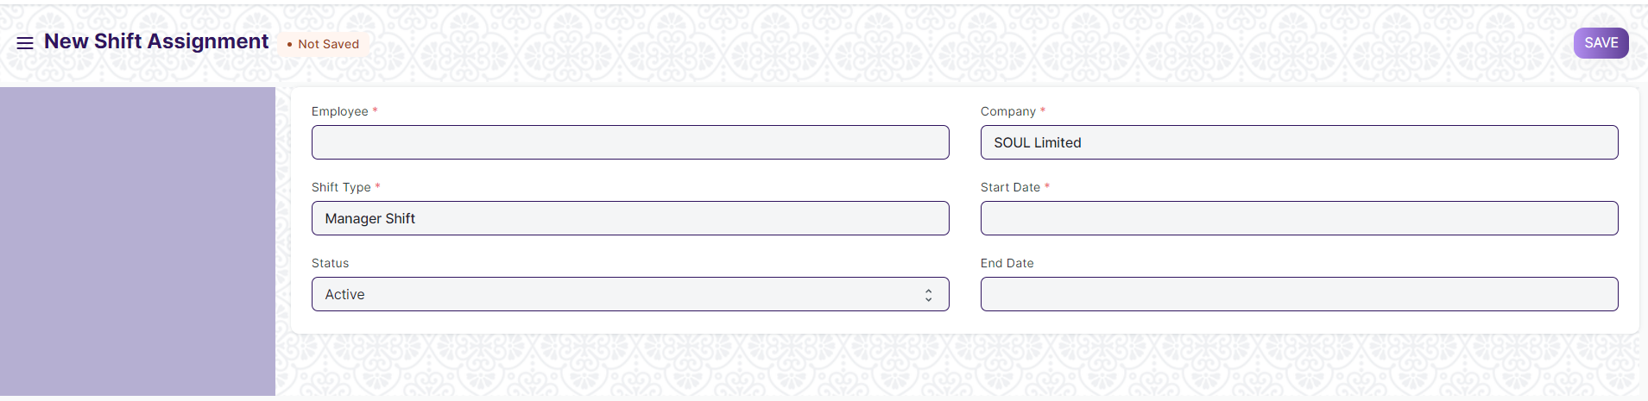

Figure 9 : Shift Assignment Screen

**Field List**

The following table describes the UI fields present in this screen :

|  |  |  |  |  |  |  |
| --- | --- | --- | --- | --- | --- | --- |
| **ID** | **Label** | **Type** | **Mandatory** | **Validation / Action** | **Remarks** | **R = Rename**  **N= New**  **D= Delete** |
| 1 | Employee | Link | Yes | Link Fields to Employee Screen |  |  |
| 2 | Employee Name | Text |  | Employee name will be fetched on selection of Employee ID |  |  |
| 3 | Shift Type | Link | Yes | Link Fields to the master screen Shift Type |  |  |
| 4 | Status | Drop down |  | Options :  Active  Ina |  |  |
| 5 | Company | Link | Yes | Link Fields to Master Screen Company | Default company name will be fetched |  |
| 6 | Start Date | Date | Yes | User will select the start date |  |  |
| 7 | End Date | Date |  | User will select end date |  |  |
| 8 | Shift Request | Link |  | Link Field to Shift Request screen |  |  |
| 9 | Department | Link |  | Link Fields to Master Screen Department | Department of Employee will be fetched. |  |

**User: Roles & Permission**

The following table describes the users and their roles and permissions for the screens :

|  |  |  |  |  |  |  |  |  |  |
| --- | --- | --- | --- | --- | --- | --- | --- | --- | --- |
| **ID** | **Role** | **Select** | **Read** | **Write** | **Create** | **Delete** | **Submit** | **Cancel** | **Amend** |
| 1 | HR Admin/Director Admin | Yes | Yes | Yes | Yes | Yes | Yes | Yes | Yes |
| 2 | HR Manager/CS | No | Yes | Yes | Yes | No | Yes | No | No |
| 3 | HR Assistant | No | Yes | No | No | No | No | No | No |
| 4 | Employee | No | Yes | No | No | No | No | No | No |

### Shift Request

**General Description**

The following table describes overall information about this screen:

|  |  |
| --- | --- |
| **Description** | 1. Shift Request is used by an employee to request for a particular Shift Type. |
| **Navigation** | Home > HRMS > Shift Management > Shift Request |
| **Pre-requisites** | The system should have records in the following screen:   1. Employee 2. Shift Type |
| **Existing Screen Name** | Shift Request |
| **New Screen Name** | No change |

**Screenshot**

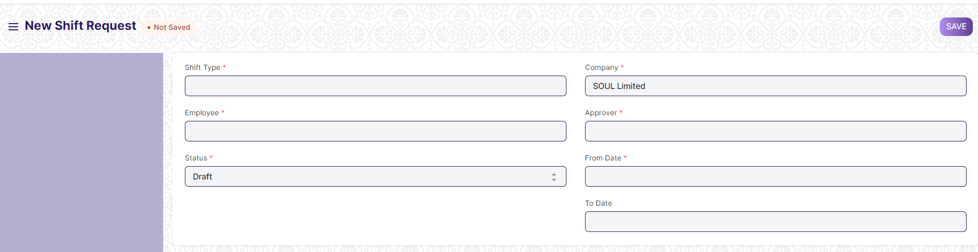

Figure 10 : Shift Request Screen

**Field List**

The following table describes the UI fields present in this screen :

|  |  |  |  |  |  |  |
| --- | --- | --- | --- | --- | --- | --- |
| **ID** | **Label** | **Type** | **Mandatory** | **Validation/ Action** | **Remarks** | **R = Rename**  **N= New**  **D= Delete** |
| 1 | Shift Type | Link | Yes | Link Fields to the master screen Shift Type |  |  |
| 2 | Employee | Link | Yes | Link Fields to Employee Screen |  |  |
| 3 | Employee Name | Text |  | Employee name will be fetched on selection of Employee ID |  |  |
| 4 | Company | Link | Yes | Link Fields to Master Screen Company | Default company name will be fetched |  |
| 5 | Department | Link | Yes | Link Fields to Master Screen Department | Department of Employee will be fetched. |  |
| 6 | Approver | Link | Yes | Link Fields to User screen | Approver of the selected employee will be fetched from employee screen. |  |
| 7 | Status | Drop down | Yes | Options :  Draft  Approved  Rejected |  |  |
| 8 | From Date | Date | Yes | User will select the date |  |  |
| 9 | To Date | Date |  | User will select the date |  |  |

**Note** :

**1.Workflow**

1. On submission of Shift Request by an Employee,It will be forwarded to the recommending authority along with HR.
2. The recommending authority will verify and forward it to the approving authority.
3. Approving authority will either approve or reject the request,it will be notified to the HR.
4. HR will update the Shift of the Employee as per the request.

**User: Roles & Permission**

The following table describes the users and their roles and permissions for the screens :

|  |  |  |  |  |  |  |  |  |  |
| --- | --- | --- | --- | --- | --- | --- | --- | --- | --- |
| **ID** | **Role** | **Select** | **Read** | **Write** | **Create** | **Delete** | **Submit** | **Cancel** | **Amend** |
| 1 | HR Admin/Director Admin | Yes | Yes | Yes | Yes | Yes | Yes | Yes | Yes |
| 2 | HR Manager/CS | No | Yes | Yes | Yes | Yes | Yes | Yes | Yes |
| 3 | HR Assistant | No | Yes | No | No | No | No | No | No |
| 4 | Employee | No | Yes | Yes | Yes | No | No | No | No |

## Leave Management

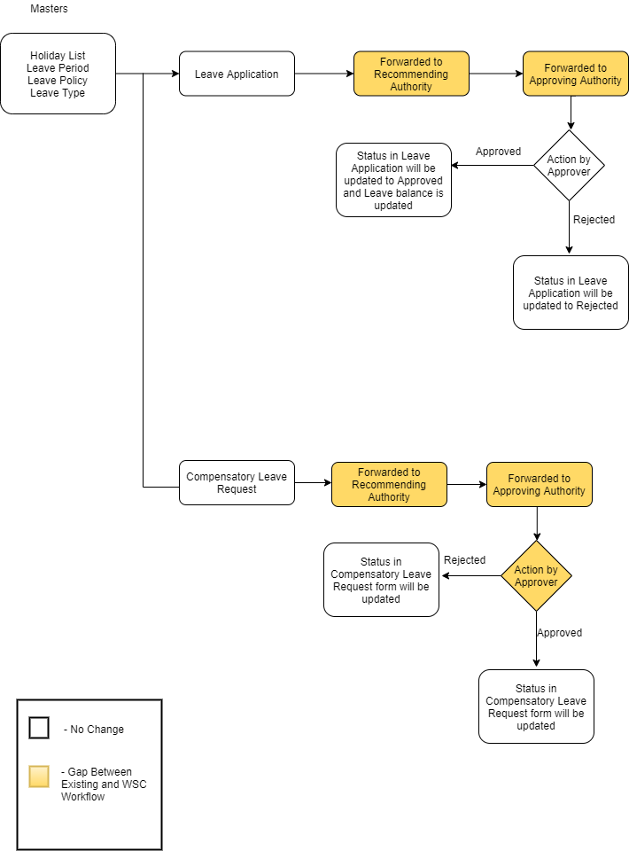

Figure 11 : Leave Management Workflow

**Description:**

**Masters**

The Leave Management module needs the following master data.

* Holiday List
* Leave Policy
* Leave Period
* Leave Type

**Leave Application**

Leave Application is a formal document created by an Employee to apply for Leaves for a particular time period.It will forwarded to approving authority by recommending authority.If the Leave is approved Leave balance will be updated.

**Compensatory Leave Request**

Application allows Employees to request for Compensatory Leaves through the Compensatory Leave Request document. It is necessary that the dates mentioned in the Compensatory Leave Request should be in default Holiday List and also that the Employee should have their attendance marked Present.

It will be forwarded to Approving authority by recommending authority.

### Holiday List

**General Description**

The Following table describe overall information about this screen:

|  |  |  |
| --- | --- | --- |
| **Description** | | 1. Holiday List is a list which contains the dates of holidays. 2. User can configure multiple Holiday Lists and assign them to your employees based on your requirements. |
| **Navigation** | Home > HRMS> Leaves > Holiday List | |
| **Pre-requisites** | The system should have records in the following screen:   1. Company | |
| **Existing Screen Name** | Holiday List | |
| **New Screen Name** | No change | |

**Screenshot**

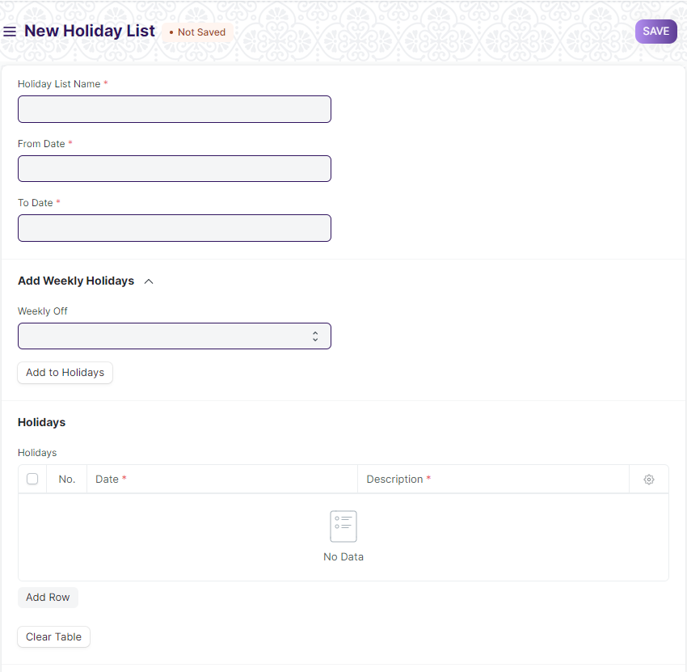

Figure 12: Holiday List Screen

**Field List**

The following table describes the UI fields present in this screen :

|  |  |  |  |  |  |  |
| --- | --- | --- | --- | --- | --- | --- |
| **ID** | **Label** | **Type** | **Mandatory** | **Validation/ Action** | **Remarks** | **R = Rename**  **N= New**  **D= Delete** |
| 1 | Holiday List Name | Text | Yes |  |  |  |
| 2 | From Date | Date | Yes |  |  |  |
| 3 | To Date | Date | Yes |  |  |  |
| 4 | Total Holidays | Number |  | Total number of Holidays will be calculated automatically based on Weekly off selected and holidays in the holiday table. |  |  |
| 5 | Weekly Off | Dropdown |  | Options:  Sunday  Monday  Tuesday  Wednesday  Thursday  Friday  Saturday | Select single or multiple options |  |
| 6 | Add to Holidays | Button |  | If clicked it will add the selected days as weekly off in the holiday list in holiday table. |  |  |
| 7 | Holidays | Table |  |  | This table is described below. |  |
| 8 | Clear Table | Button |  | If clicked,it will clear the Holiday table. |  |  |
| Holidays | | | | | | |
| **ID** | **Label** | **Type** | **Mandatory** | **Validation/ Action** | **Remarks** | **R = Rename**  **N= New**  **D= Delete** |
| 1 | Date | Date | Yes |  |  |  |
| 2 | Weekly Off | Checkbox |  | If checked,that holiday is marked as weekly off. |  |  |
| 3 | Description | Text |  |  |  |  |

**User: Roles & Permission**

The following table describes the users and their roles and permissions for the screens :

|  |  |  |  |  |  |  |  |  |  |
| --- | --- | --- | --- | --- | --- | --- | --- | --- | --- |
| **ID** | **Role** | **Select** | **Read** | **Write** | **Create** | **Delete** | **Submit** | **Cancel** | **Amend** |
| 1 | HR Admin/Director Admin | Yes | Yes | Yes | Yes | Yes | NA | NA | NA |
| 2 | HR Manager/CS | No | Yes | Yes | Yes | No | NA | NA | NA |
| 3 | HR Assistant | No | Yes | No | No | No | NA | NA | NA |
| 4 | Employee | No | Yes | No | No | No | NA | NA | NA |

### Leave Type

**General Description**

The Following table describe overall information about this screen:

|  |  |  |
| --- | --- | --- |
| **Description** | | 1. Leave Type refers to the types of leaves allocated to an Employee which they can use while making Leave Applications. |
| **Navigation** | Home > HRMS> Leaves > Leave Type | |
| **Pre-requisites** | The system should have records in the following screen:   1. Employment Type | |
| **Existing Screen Name** | Leave Type | |
| **New Screen Name** | No change | |

**Screenshot**

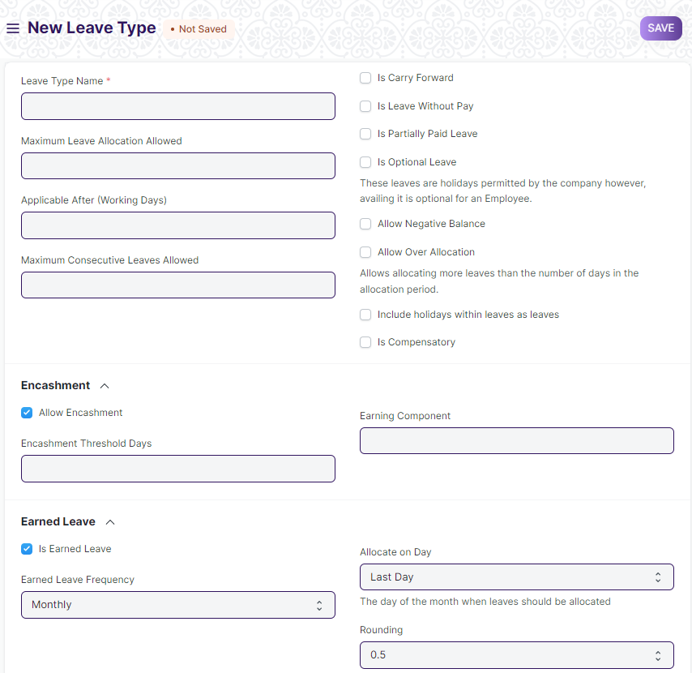

Figure 13 : Leave Type Screen

**Field List**

The following table describes the UI fields present in this screen :

|  |  |  |  |  |  |  |
| --- | --- | --- | --- | --- | --- | --- |
| **ID** | **Label** | **Type** | **Mandatory** | **Validation/ Action** | **Remarks** | **R = Rename**  **N= New**  **D= Delete** |
| 1 | Leave Type Name | Text | Yes |  |  |  |
| 2 | Maximum Leave Allocation Allowed | Number |  |  |  |  |
| 3. | Employment Type | Link | Yes | Link field to Master Screen”Employment Type” |  | N |
| 3 | Applicable After (Working Days) | Number |  |  |  |  |
| 4 | Maximum Consecutive Leaves Allowed | Number |  |  |  |  |
| 5 | Is Carry Forward | Checkbox |  | If checked ,the balance leaves of this type will be carried forward to next allocation period |  |  |
| 6 | Is Leave Without Pay | Checkbox |  | If checked,the leave type will be treated as leaves without pay and salary will be deducted. |  |  |
| 7 | Is Partially Paid Leave | Checkbox |  | If checked,the leave type will be treated as partially paid and some part of daily earnings will be paid through salary slip. |  |  |
| 8 | Fraction of Daily Salary per Leave | Float |  | If “Is Partially Paid Leave”is checked,this field will appear. |  |  |
| 9 | Is Optional Leave | Checkbox |  |  |  |  |
| 10 | Allow Negative Balance | Checkbox |  | If checked,the system will allow allocating more leaves than the number of days in the allocation period. |  |  |
| 11 | Allow Over Allocation | Checkbox |  | If checked,the system will allow allocating more leaves than the number of days in the allocation period. |  |  |
| 12 | Include holidays within leaves as leaves | Checkbox |  | If checked,count holidays within leaves as a ‘leave’. |  |  |
| 13 | Is Compensatory | Checkbox |  | If checked,the leave type is marked as compensatory |  |  |
| 14 | Maximum Carry Forwarded Leaves | Float |  | If “Is Carry Forward”is checked,this field will appear. |  |  |
| 15 | Expire Carry Forwarded Leaves (Days) | Number |  | If “Is Carry Forward”is checked,this field will appear. |  |  |
| 16 | Allow Encashment | Checkbox |  | If checked,below two fields will appear. |  |  |
| 17 | Encashment Threshold Days | Number |  | If “Allow Encashment” is checked,this field will appear. |  |  |
| 18 | Earning Component | Link |  | If “Allow Encashment” is checked,this field will appear. |  |  |
| 19 | Is Earned Leave | Checkbox |  | If checked,below two fields will appear. |  |  |
| 20 | Earned Leave Frequency | Dropdown |  | If “Is Earned Leave”is checked,this field will appear.  **Options:**  Monthly  Quarterly  Half-Yearly  Yearly |  |  |
| 21 | Allocate on Day | Dropdown |  | If “Is Earned Leave”is checked,this field will appear  **Options:**  **First Day**  **Last Day**  **Date of Joining** |  |  |
| 22 | Rounding | Dropdown |  | If “Is Earned Leave”is checked,this field will appear.  **Options:**  0.25  0.5  1.0 |  |  |

**Note** :

**1.Validation**

1. Leave Type will be dependent on Employment Type(Deputation/OMCE/Consultant/Guest/Outsourced).

**User: Roles & Permission**

The following table describes the users and their roles and permissions for the screens :

|  |  |  |  |  |  |  |  |  |  |
| --- | --- | --- | --- | --- | --- | --- | --- | --- | --- |
| **ID** | **Role** | **Select** | **Read** | **Write** | **Create** | **Delete** | **Submit** | **Cancel** | **Amend** |
| 1 | HR Admin/Director Admin | Yes | Yes | Yes | Yes | Yes | NA | NA | NA |
| 2 | HR Manager/CS | No | Yes | Yes | Yes | No | NA | NA | NA |
| 3 | HR Assistant | No | Yes | No | No | No | NA | NA | NA |
| 4 | Employee | No | Yes | No | No | No | NA | NA | NA |

### Leave Period

**General Description**

The Following table describe overall information about this screen:

|  |  |  |
| --- | --- | --- |
| **Description** | | 1. Leave Period is a duration of time for which leaves are allocated. |
| **Navigation** | Home > HRMS> Leaves > Leave Period | |
| **Pre-requisites** | The system should have records in the following screen:   1. Company 2. Holiday List | |
| **Existing Screen Name** | Leave Period | |
| **New Screen Name** | No change | |

**Screenshot**

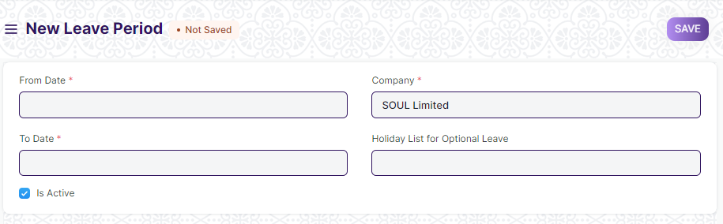

Figure 14 : Leave Period Screen

**Field List**

The following table describes the UI fields present in this screen :

|  |  |  |  |  |  |  |
| --- | --- | --- | --- | --- | --- | --- |
| **ID** | **Label** | **Type** | **Mandatory** | **Validation/ Action** | **Remarks** | **R = Rename**  **N= New**  **D= Delete** |
| 1 | From Date | Date | Yes |  |  |  |
| 2 | To Date | Date | Yes |  |  |  |
| 3. | Is Active | Checkbox |  | “Is Active”is checked ,to make leave period active. |  |  |
| 4 | Company | Link | Yes | “Company”will be auto-populated as per the settings |  |  |
| 5 | Holiday List for Optional Leaves | Link |  | Link to the master “Holiday List” |  |  |

**1.Validation**

1. Leave Period is based on the Joining Date.

**User: Roles & Permission**

The following table describes the users and their roles and permissions for the screens :

|  |  |  |  |  |  |  |  |  |  |
| --- | --- | --- | --- | --- | --- | --- | --- | --- | --- |
| **ID** | **Role** | **Select** | **Read** | **Write** | **Create** | **Delete** | **Submit** | **Cancel** | **Amend** |
| 1 | HR Admin/Director Admin | Yes | Yes | Yes | Yes | Yes | NA | NA | NA |
| 2 | HR Manager/CS | No | Yes | Yes | Yes | No | NA | NA | NA |
| 3 | HR Assistant | No | Yes | No | No | No | NA | NA | NA |
| 4 | Employee | No | Yes | No | No | No | NA | NA | NA |

### Leave Policy

**General Description**

The Following table describe overall information about this screen:

|  |  |  |
| --- | --- | --- |
| **Description** | | 1. Leave Policy is the amount of entitled leaves in a Company for an Employee in a Leave Period. |
| **Navigation** | Home > HRMS> Leaves > Leave Policy | |
| **Pre-requisites** | The system should have records in the following screen:   1. Leave Type | |
| **Existing Screen Name** | Leave Policy | |
| **New Screen Name** | No change | |

**Screenshot**

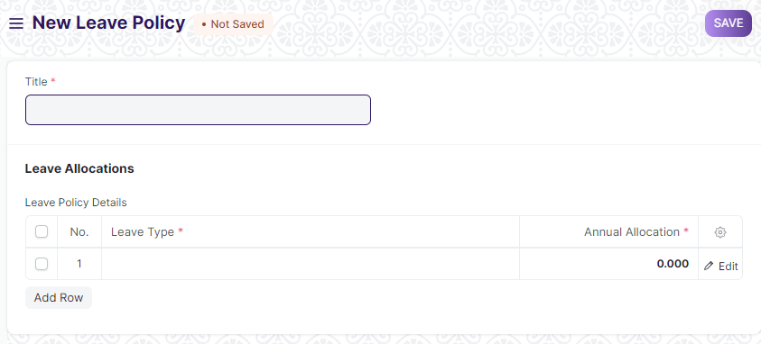

Figure 15 : Leave Policy Screen

**Field List**

The following table describes the UI fields present in this screen :

|  |  |  |  |  |  |  |
| --- | --- | --- | --- | --- | --- | --- |
| **ID** | **Label** | **Type** | **Mandatory** | **Validation/ Action** | **Remarks** | **R = Rename**  **N= New**  **D= Delete** |
| 1 | Title | Text | Yes |  |  |  |
| 2 | Leave Policy Attachment | Attach | Yes |  |  |  |
| 3 | Employment Type | Link |  | Link to master “Employment Type” |  |  |
| 3 | Leave Policy Details | Table | Yes |  | This table is described below |  |
|  | Action | Button |  | Button will appear once the form is submitted. |  | N |
|  | Approve |  |  | It will show in Action Button ,once approved the status of the document will be changed to Approved. |  |  |
|  | Reject |  |  | It will show in Action Button,once rejected the status of the document will changed to rejected. |  |  |
| Leave Policy Detail | | | | | | |
| **ID** | **Label** | **Type** | **Mandatory** | **Validation/ Action** | **Remarks** | **R = Rename**  **N= New**  **D= Delete** |
| 1 | Leave Type | Link | Yes | Link to the master screen “Leave Type”. |  |  |
| 2 | Annual Allocation | Float | Yes |  |  |  |

**User: Roles & Permission**

The following table describes the users and their roles and permissions for the screens :

|  |  |  |  |  |  |  |  |  |  |
| --- | --- | --- | --- | --- | --- | --- | --- | --- | --- |
| **ID** | **Role** | **Select** | **Read** | **Write** | **Create** | **Delete** | **Submit** | **Cancel** | **Amend** |
| 1 | HR Admin/Director Admin | Yes | Yes | Yes | Yes | Yes | Yes | Yes | Yes |
| 2 | HR Manager/CS | No | Yes | Yes | Yes | Yes | Yes | Yes | Yes |
| 3 | HR Assistant | No | Yes | No | No | No | No | No | No |
| 4 | Employee | No | Yes | No | No | No | No | No | No |

### Leave Block List

**General Description**

The Following table describe overall information about this screen:

|  |  |  |
| --- | --- | --- |
| **Description** | | 1. Leave Block List is a list of dates in a year, on which employees cannot apply for leave. |
| **Navigation** | Home > HRMS> Leaves > Leave Block List | |
| **Pre-requisites** | The system should have records in the following screen:   1. Company 2. Department 3. Leave Period 4. Holiday List | |
| **Existing Screen Name** | Leave Block List | |
| **New Screen Name** | No change | |

**Screenshot**

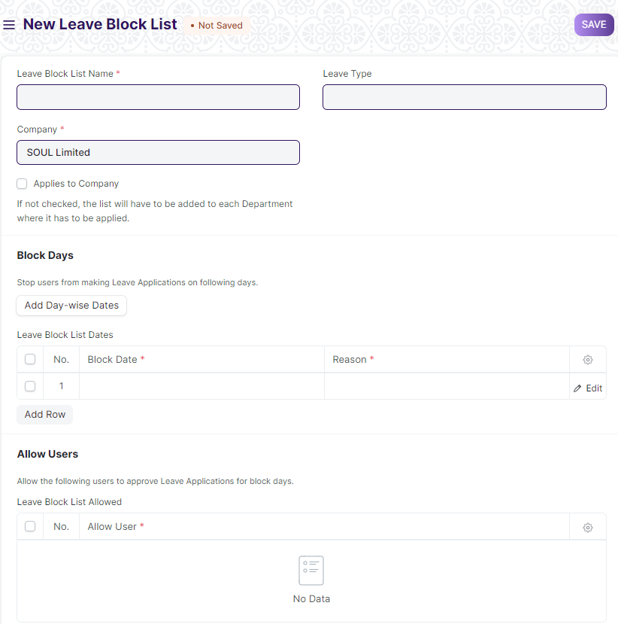

Figure 16 : Leave Block List Screen

**Field List**

The following table describes the UI fields present in this screen :

|  |  |  |  |  |  |  |
| --- | --- | --- | --- | --- | --- | --- |
| **ID** | **Label** | **Type** | **Mandatory** | **Validation/ Action** | **Remarks** | **R = Rename**  **N= New**  **D= Delete** |
| 1 | Leave Block List Name | Text | Yes |  |  |  |
| 2 | Company | Link | Yes | Company will be auto-populated as per the settings. |  |  |
| 3 | Applies to Company | Checkbox |  | If checked,this block list will be applied to the entire company and department. |  |  |
| 4 | Employment Type | Link | Yes | Link to Master Screen “Employment Type” |  |  |
| 4 | Leave Type | Link |  | Link to Master Screen “Leave Type.” |  |  |
| 5 | Add Day-wise Dates | Button |  |  |  |  |
| 6 | Leave Block List Dates | Table | Yes |  | This table is described below |  |
| 7 | Leave Block List Allowed | Table |  |  | This table is described below |  |
| Leave Block List Date | | | | | | |
| **ID** | **Label** | **Type** | **Mandatory** | **Validation/ Action** | **Remarks** | **R = Rename**  **N= New**  **D= Delete** |
| 1 | Block Date | Date | Yes |  |  |  |
| 2 | Reason | Text | Yes |  |  |  |
| Leave Block List Allowed | | | | | | |
| **ID** | **Label** | **Type** | **Mandatory** | **Validation/ Action** | **Remarks** | **R = Rename**  **N= New**  **D= Delete** |
| 1 | Allow User | Link | Yes |  |  |  |

**Note** :

**1.Validation**

1. Leave Policy will be dependent on Employment Type(Deputation/OMCE/Consultant/Guest/Outsourced).

**User: Roles & Permission**

The following table describes the users and their roles and permissions for the screens :

|  |  |  |  |  |  |  |  |  |  |
| --- | --- | --- | --- | --- | --- | --- | --- | --- | --- |
| **ID** | **Role** | **Select** | **Read** | **Write** | **Create** | **Delete** | **Submit** | **Cancel** | **Amend** |
| 1 | HR Admin/Director Admin | Yes | Yes | Yes | Yes | Yes | NA | NA | NA |
| 2 | HR Manager/CS | No | Yes | Yes | Yes | No | NA | NA | NA |
| 3 | HR Assistant | No | Yes | No | No | No | NA | NA | NA |
| 4 | Employee | No | Yes | No | No | No | NA | NA | NA |

### Leave Policy Assignment

**General Description**

The Following table describe overall information about this screen:

|  |  |  |
| --- | --- | --- |
| **Description** | | 1. Leave Policy Assignment in ERPNext is used to assign leaves to employees based on created policies |
| **Navigation** | Home > HRMS> Leaves> Leave Policy Assignment | |
| **Pre-requisites** | The system should have records in the following screen:   1. Employee 2. Leave Policy | |
| **Existing Screen Name** | Leave Policy Assignment | |
| **New Screen Name** | No change | |

**Screenshot**

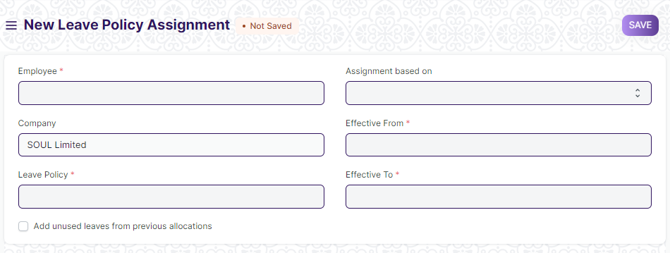

Figure 17: Leave Policy Assignment Screen

**Field List**

The following table describes the UI fields present in this screen :

|  |  |  |  |  |  |  |
| --- | --- | --- | --- | --- | --- | --- |
| **ID** | **Label** | **Type** | **Mandatory** | **Validation/ Action** | **Remarks** | **R = Rename**  **N= New**  **D= Delete** |
| 1 | Employee | Link | Yes |  |  |  |
| 2 | Employee name | Link |  | Employee name will be auto-populated on the basis of Employee Id Selected. |  |  |
| 3 | Company | Link |  | Company field will be auto-populated on the basis of settings. |  |  |
| 4 | Leave Policy | Link | Yes | Link to the master screen Leave Policy |  |  |
| 5 | Add unused leaves from previous allocations | Checkbox |  | If checked,unused leave from previous allocation will be added. |  |  |
| 6 | Assignment based on | Dropdown |  | Options:   1. Leave Period 2. Joining Date |  |  |
| 7 | Leave Period | Link |  | Link to the master screen Leave Period |  |  |
| 8 | Effective From | Date | Yes |  |  |  |
| 9 | Effective To | Date | Yes |  |  |  |
| 10 | Leaves Allocated | Checkbox |  | If checked,on submit the Leave Allocation is created in Leave Allocation Form. |  |  |
|  | Bulk Leave Policy Assignment | Button |  | A button is present in List view of the form.It can be used to assign leave Policy in Bulk.On click a Dialog will appear.  **Dialog details:**   1. Select Employees on the basis of filters like Department. 2. Select Leave Policy 3. Select Assignment based on and effective date . 4. Assign the policy |  |  |

**Note:**

1.On the submission of the Form,Leave Allocation will be added automatically in the Leave Allocation Form.

**User: Roles & Permission**

The following table describes the users and their roles and permissions for the screens :

|  |  |  |  |  |  |  |  |  |  |
| --- | --- | --- | --- | --- | --- | --- | --- | --- | --- |
| **ID** | **Role** | **Select** | **Read** | **Write** | **Create** | **Delete** | **Submit** | **Cancel** | **Amend** |
| 1 | HR Admin/Director Admin | Yes | Yes | Yes | Yes | Yes | Yes | Yes | Yes |
| 2 | HR Manager/CS | No | Yes | Yes | Yes | No | Yes | Yes | No |
| 3 | HR Assistant | No | Yes | No | No | No | No | No | No |
| 4 | Employee | No | No | No | No | No | No | No | No |

### Leave Allocation

**General Description**

The Following table describe overall information about this screen:

|  |  |  |
| --- | --- | --- |
| **Description** | | 1. Leave Allocation enables you to allocate a specific number of leaves of a particular type to an Employee. |
| **Navigation** | Home > HRMS> Leaves> Leave Allocation | |
| **Pre-requisites** | The system should have records in the following screen:   1. Employee 2. Leave Type 3. Leave Period 4. Leave Policy | |
| **Existing Screen Name** | Leave Policy Assignment | |
| **New Screen Name** | No change | |

**Screenshot**

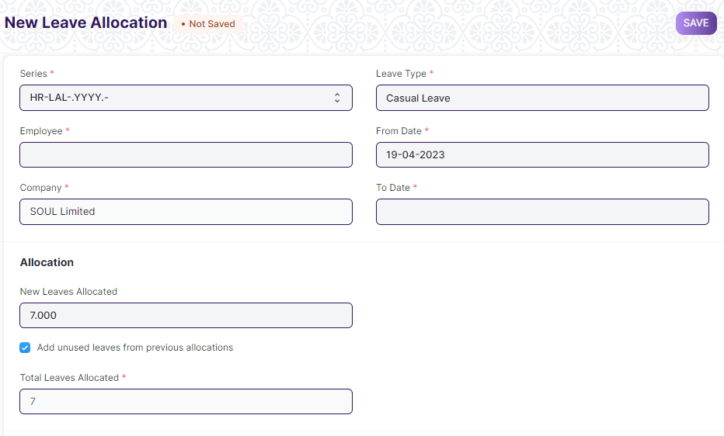

Figure 18 : Leave Allocation Screen

**Field List**

The following table describes the UI fields present in this screen :

|  |  |  |  |  |  |  |
| --- | --- | --- | --- | --- | --- | --- |
| **ID** | **Label** | **Type** | **Mandatory** | **Validation/ Action** | **Remarks** | **R = Rename**  **N= New**  **D= Delete** |
| 1 | Series | Dropdown | Yes |  |  |  |
| 2 | Employee | Link | Yes | Employee name will be auto-populated on the basis of Employee Id Selected. |  |  |
| 3 | Employee Name | Text |  | Employee name will be auto-populated on the basis of Employee Id Selected. |  |  |
| 4 | Department | Link | Yes | Department will be auto-populated on the basis of Employee Id Selected. |  |  |
| 5 | Company | Link | Yes | Company will be auto-populated on the basis of Employee Id Selected. |  |  |
| 6 | Leave Type | Link |  | Link to the master screen Leave Type |  |  |
| 7 | From Date | Date |  | Link to the master screen Leave Period |  |  |
| 8 | To Date | Date |  |  |  |  |
| 9 | New Leaves Allocated | Float |  |  |  |  |
| 10 | Add unused leaves from previous allocations | Checkbox |  |  |  |  |
| 11 | Unused leaves | Float |  |  |  |  |
| 12 | Total Leaves Allocated | Float |  |  |  |  |
| 13 | Total Leaves Encashed | Float |  |  |  |  |
| 14 | Compensatory Leave Request | Link |  | Link to the screen Compensatory Leave Request |  |  |
| 15 | Leave Period | Link |  | Link to the screen Leave Period |  |  |
| 16 | Leave Policy | Link |  | Link to the screen Leave Policy |  |  |
| 17 | Leave Policy Assignment | Link |  | Link to the screen Leave Policy Assignment |  |  |
| 18 | Carry Forwarded Leaves | Float |  |  |  |  |
| 19 | Expired | Checkbox |  |  |  |  |

**User: Roles & Permission**

The following table describes the users and their roles and permissions for the screens :

|  |  |  |  |  |  |  |  |  |  |
| --- | --- | --- | --- | --- | --- | --- | --- | --- | --- |
| **ID** | **Role** | **Select** | **Read** | **Write** | **Create** | **Delete** | **Submit** | **Cancel** | **Amend** |
| 1 | HR Admin/Director Admin | Yes | Yes | Yes | Yes | Yes | Yes | Yes | Yes |
| 2 | HR Manager | No | Yes | Yes | Yes | No | Yes | Yes | No |
| 3 | HR Assistant | No | Yes | No | No | No | No | No | No |
| 4 | Employee | No | No | No | No | No | No | No | No |

### Leave Application

**General Description**

The Following table describe overall information about this screen:

|  |  |  |
| --- | --- | --- |
| **Description** | | 1. Leave Application is a formal document created by an Employee to apply for Leaves for a particular time period. |
| **Navigation** | Home > HRMS> Leaves> Leave Application | |
| **Pre-requisites** | The system should have records in the following screen:   1. Department 2. Leave Period 3. Holiday List 4. Leave Type 5. Leave Policy 6. Leave Allocation | |
| **Existing Screen Name** | Leave Application | |
| **New Screen Name** | No change | |

**Screenshot**

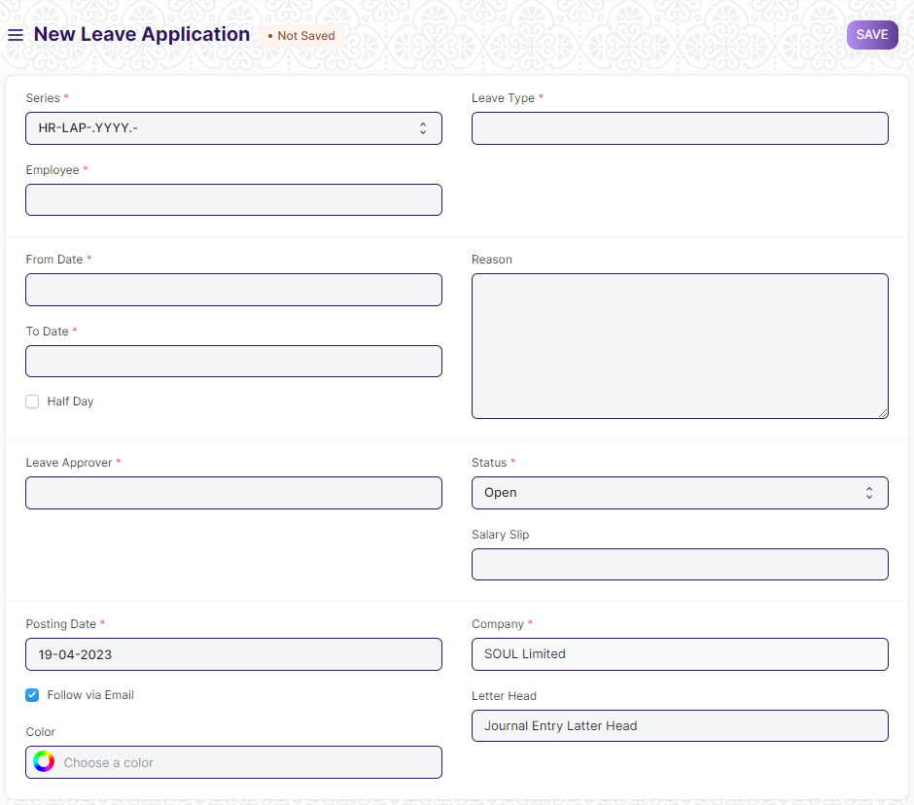

Figure 19 : Leave Application Screen

**Field List**

The following table describes the UI fields present in this screen :

|  |  |  |  |  |  |  |
| --- | --- | --- | --- | --- | --- | --- |
| **ID** | **Label** | **Type** | **Mandatory** | **Validation/ Action** | **Remarks** | **R = Rename**  **N= New**  **D= Delete** |
| 1 | Series | Dropdown | Yes |  |  |  |
| 2 | Employee | Link | Yes | Link to master screen Employee |  |  |
| 3 | Employee Name | Text |  | Employee name will be auto-populated on the basis of Employee Id Selected. |  |  |
| 4 | Department | Link | Yes | Department will be auto-populated on the basis of Employee Id Selected. |  |  |
| 5 | Employment Type | Text | Yes | Employment type will be auto-populated on the basis of Employee Id. |  |  |
| 6 | Leave Type | Link | Yes | Link to the master screen Leave Type |  |  |
| 7 | Leave Balance Before Application | Float |  |  |  |  |
| 8 | From Date | Date | Yes |  |  |  |
| 9 | To Date | Date | Yes |  |  |  |
| 10 | Half Day | Checkbox |  |  |  |  |
| 11 | Half Day Date | Date |  |  |  |  |
| 12 | Total Leave Days | Float |  |  |  |  |
| 13 | Reason | Float |  |  |  |  |
| 14 | Leave Approver | Link |  | Approver will auto fetch from employee |  |  |
| 15 | Leave Approver Name | Text |  |  |  |  |
| 16 | Status | Dropdown | Yes | Option:   1. Open 2. Approved 3. Rejected 4. Cancelled |  |  |
| 17 | Salary Slip | Link |  | Link to the screen Salary Slip |  |  |
| 18 | Posting Date | Date | Yes |  |  |  |
| 19 | Company | Link | Yes |  |  |  |
| 20 | Letter Head | Link |  |  |  |  |
|  | Action |  |  | Once the form will be submitted the action button will appear. |  |  |
|  | Approved |  |  | In action button Approved option will be present. |  |  |
|  | Reject |  |  | In action button Reject option will be present. |  |  |

**Note** :

**1.Workflow**

1. Employee will apply for leave.
2. It will be forwarded to recommending authority.Recommending authority will verify and forward it to the approving authority.
3. Approving authority will approve/reject the request.
4. Once the Leave is approved ,the Leave balance will be updated.

**2.Notification**

1. Email will be triggered along with the link of the leave application to the recommending and approving authority.

**User: Roles & Permission**

The following table describes the users and their roles and permissions for the screens :

|  |  |  |  |  |  |  |  |  |  |
| --- | --- | --- | --- | --- | --- | --- | --- | --- | --- |
| **ID** | **Role** | **Select** | **Read** | **Write** | **Create** | **Delete** | **Submit** | **Cancel** | **Amend** |
| 1 | HR Admin/Director Admin | Yes | Yes | Yes | Yes | Yes | Yes | Yes | Yes |
| 2 | HR Manager | No | Yes | Yes | Yes | No | Yes | Yes | No |
| 3 | HR Assistant | No | Yes | No | No | No | No | No | No |
| 4 | Employee | No | Yes | Yes | Yes | Yes | Yes | Yes | Yes |

### Leave Encashment

**General Description**

The Following table describe overall information about this screen:

|  |  |  |
| --- | --- | --- |
| **Description** | | 1. Leave Encashment refers to an amount of money received in exchange for Leaves not availed by an Employee. You can submit Leave Encashment for Leave Types which are encashable****.**** |
| **Navigation** | Home > HRMS> Leaves> Leave Encashment | |
| **Pre-requisites** | The system should have records in the following screen:   1. Employee 2. Leave Type 3. Leave Policy 4. Salary Structure 5. Salary Structure Assignment | |
| **Existing Screen Name** | Leave Encashment | |
| **New Screen Name** | No change | |

**Screenshot**

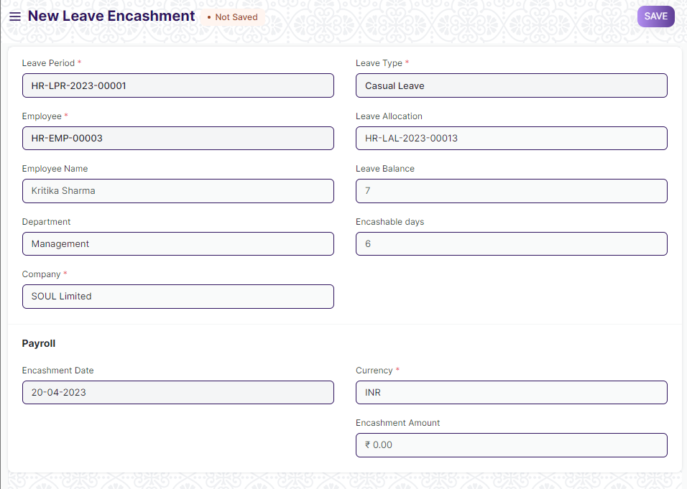

Figure 20 : Leave Encashment Screen

**Field List**

The following table describes the UI fields present in this screen :

|  |  |  |  |  |  |  |
| --- | --- | --- | --- | --- | --- | --- |
| **ID** | **Label** | **Type** | **Mandatory** | **Validation/ Action** | **Remarks** | **R = Rename**  **N= New**  **D= Delete** |
| 1 | Leave Period | Link | Yes | Link to master screen Leave Period |  |  |
| 2 | Employee | Link | Yes | Link to master screen Employee |  |  |
| 3 | Employee Name | Text |  | Employee name will be auto-populated on the basis of Employee Id Selected. |  |  |
| 4 | Department | Link |  | Department will be auto-populated on the basis of Employee Id Selected. |  |  |
| 5 | Employment Type | Text |  | Employment type will be auto-populated on the basis of Employee Id. |  |  |
| 6 | Company | Link |  | Company will be auto-populated on the basis of setting. |  |  |
| 7 | Leave Type | Link | Yes | Link to the master screen Leave Type |  |  |
| 8 | Leave Allocation | Link |  | Link to screen Leave Allocation |  |  |
| 9 | Leave Balance | Float |  | Leave balance will be auto-populated on the basis of leave allocation |  |  |
| 10 | Encashable days | Float |  | Encashable days will be auto-populated on the basis of Leave Type and Leave Allocation |  |  |
| 11 | Encashment Date | Date |  |  |  |  |
| 11 | Additional Salary | Link |  |  |  |  |
| 12 | Currency | Link |  |  |  |  |
| 13 | Encashment Amount | Currency |  |  |  |  |

**User: Roles & Permission**

The following table describes the users and their roles and permissions for the screens :

|  |  |  |  |  |  |  |  |  |  |
| --- | --- | --- | --- | --- | --- | --- | --- | --- | --- |
| **ID** | **Role** | **Select** | **Read** | **Write** | **Create** | **Delete** | **Submit** | **Cancel** | **Amend** |
| 1 | HR Admin/Director Admin | Yes | Yes | Yes | Yes | Yes | Yes | Yes | Yes |
| 2 | HR Manager | No | Yes | Yes | Yes | Yes | Yes | Yes | Yes |
| 3 | HR Assistant | No | Yes | No | No | No | No | No | No |
| 4 | Employee | No | Yes | Yes | Yes | Yes | Yes | Yes | Yes |

### Compensatory Leave Request

**General Description**

The Following table describe overall information about this screen:

|  |  |  |
| --- | --- | --- |
| **Description** | | 1. Compensatory Leave is a leave that is granted to an Employee as compensation for working overtime or on holidays. 2. Application allows Employees to request for Compensatory Leaves through the Compensatory Leave Request document 3. It is necessary that the dates mentioned in the Compensatory Leave Request should be in default Holiday List and also that the Employee should have their attendance marked Present. |
| **Navigation** | Home > HRMS> Leaves> Compensatory Leave Request | |
| **Pre-requisites** | The system should have records in the following screen:   1. Employee 2. Leave Period 3. Leave Type 4. Leave Policy 5. Leave Allocation 6. Holiday List 7. Attendance | |
| **Existing Screen Name** | Compensatory Leave Request | |
| **New Screen Name** | No change | |

**Screenshot**

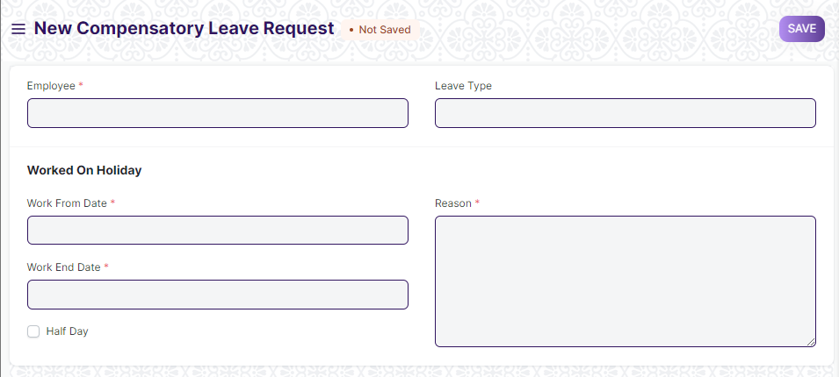

Figure 21 : Compensatory Leave Request Screen

**Field List**

The following table describes the UI fields present in this screen :

|  |  |  |  |  |  |  |
| --- | --- | --- | --- | --- | --- | --- |
| **ID** | **Label** | **Type** | **Mandatory** | **Validation/ Action** | **Remarks** | **R = Rename**  **N= New**  **D= Delete** |
| 1 | Employee | Link | Yes | Link to master screen Employee |  |  |
| 2 | Employee Name | Link | Yes | Employee name will be auto-populated on the basis of Employee Id Selected. |  |  |
| 3 | Department | Text |  | Department will be auto-populated on the basis of Employee Id Selected. |  |  |
| 4 | Employment Type | Text |  | Employment type will be auto-populated on the basis of Employee Id. |  |  |
| 5 | Leave Type | Link |  | Link to the master screen Leave Type |  |  |
| 6 | Leave Allocation | Link |  |  |  |  |
| 7 | Work From Date | Link | Yes |  |  |  |
| 8 | Work End Date | Link | Yes |  |  |  |
| 9 | Half Day | Link |  | If checked,the attendance will be marked for half day. |  |  |
| 10 | Half Day Date | Float |  |  |  |  |
| 11 | Reason | Float |  |  |  |  |
|  | Action | Button |  | Action Button will appear once the form is submitted by Employee |  |  |
|  | Approve |  |  | This button will appear in Action button. |  |  |
|  | Reject |  |  | This button will appear in Action button. |  |  |

**Note** :

**1.Workflow**

1. Employee will apply for Compensatory Leave.
2. It will be forwarded to recommending authority.Recommending authority will verify and forward it to the approving authority.
3. Approving authority will approve/reject the request.

**User: Roles & Permission**

The following table describes the users and their roles and permissions for the screens :

|  |  |  |  |  |  |  |  |  |  |
| --- | --- | --- | --- | --- | --- | --- | --- | --- | --- |
| **ID** | **Role** | **Select** | **Read** | **Write** | **Create** | **Delete** | **Submit** | **Cancel** | **Amend** |
| 1 | HR Admin/Director Admin | Yes | Yes | Yes | Yes | Yes | Yes | Yes | Yes |
| 2 | HR Manager | No | Yes | Yes | Yes | Yes | Yes | Yes | Yes |
| 3 | HR Assistant | No | Yes | No | No | No | No | No | No |
| 4 | Employee | No | Yes | Yes | Yes | Yes | Yes | Yes | Yes |

## Salary

**Masters**

### Salary Component

**General Description**

The Following table describe overall information about this screen:

|  |  |  |
| --- | --- | --- |
| **Description** | | 1. Salaries are paid by organizations to their employees in exchange for the services rendered by them. The different components that make up the Salary Structure are called as Salary Components. 2. Salary paid to the employees comprises of several different components, such as basic salary, allowances, arrears, etc |
| **Navigation** | Home > HRMS> Salary> Salary Component | |
| **Pre-requisites** | The system should have records in the following screen:   1. Company | |
| **Existing Screen Name** | Salary Component | |
| **New Screen Name** | No change | |

**Screenshot**

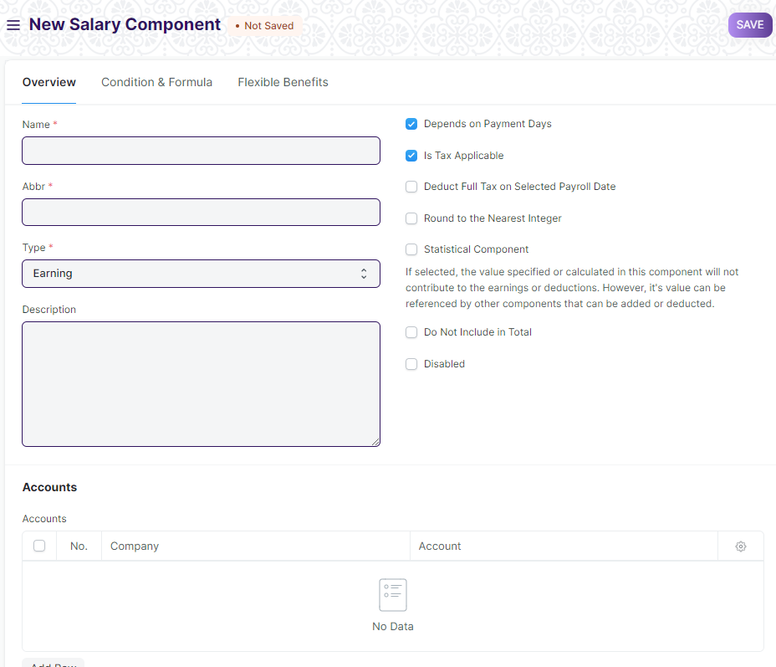

Figure 22 : Salary Component Screen

**Field List**

The following table describes the UI fields present in this screen :

|  |  |  |  |  |  |  |
| --- | --- | --- | --- | --- | --- | --- |
| **ID** | **Label** | **Type** | **Mandatory** | **Validations/Action** | **Remarks** | R = Rename  N= New  D= Delete |
| 1 | Name | Text | Yes |  |  |  |
| 2 | Abbr | Text | Yes |  |  |  |
| 3 | Type | Dropdown | Yes | **Options:**   1. Earning 2. Deduction |  |  |
| 4 | Description | Small Text |  |  |  |  |
| 5 | Component Type | Dropdown |  | **Options:**   1. Provident Fund 2. Additional 3. Provident Fund 3. Provident Fund Loan 4. Professional Tax |  |  |
| 6 | Depends on Payment Days | Checkbox |  | If this checkbox is checked,the salary component will be calculated based on number of working days. |  |  |
| 7 | Is Tax Applicable | Checkbox |  | If this checkbox is checked,it allows tax to be applied on this salary component. |  |  |
| 8 | Is Income Tax Component | Checkbox |  | If this checkbox is checked,the salary component will come under Income Tax. |  |  |
| 9 | Deduct Full Tax on Selected Payroll Date | Checkbox |  | If this check box is checked,the salary component is used in Additional Salary. |  |  |
| 10 | Variable Based On Taxable Salary | Checkbox |  | If this checkbox is checked,the salary component is calculated automatically on taxable income based on Income Tax Slab. |  |  |
| 11 | Exempted from Income Tax | Checkbox |  | If this checkbox is checked,the full amount will be deducted from taxable income before calculating income tax without any declaration. |  |  |
| 12 | Round to the Nearest Integer | Checkbox |  | If this checkbox is checked,the salary component amount will be rounded off to the nearest integer. |  |  |
| 13 | Statistical Component | Checkbox |  | If this checkbox is checked,the value specified or calculated in this component will not contribute to the earnings or deduction. |  |  |
| 14 | Do Not Include in Total | Checkbox |  | If this checkbox is checked,the salary component is not included in the Total Salary. |  |  |
| 15 | Disabled | Checkbox |  | If checked,the salary component is disabled. |  |  |
| 16 | Accounts | Table |  |  | This table is described below |  |
| 17 | Condition | Code |  | the Condition and Formula required for the calculation of the Salary Component can be specified |  |  |
| 18 | Amount | Currency |  |  |  |  |
| 19 | Amount based on formula | Checkbox |  | To specify the formula, enable the 'Amount based on formula' checkbox. |  |  |
| 20 | Formula | Code |  |  |  |  |
| 21 | Help | HTML |  |  |  |  |
| 22 | Is Flexible Benefit | Checkbox |  | If checkbox is checked,the salary component is set as a Flexible Benefit. |  |  |
| 23 | Max Benefit Amount (Yearly) | Currency |  |  |  |  |
| 24 | Pay Against Benefit Claim | Checkbox |  | If this checkbox is checked,user can pay benefit via Employee Benefit Claim. |  |  |
| 25 | Only Tax Impact (Cannot Claim But Part of Taxable Income) | Checkbox |  | If this checkbox is checked,the flexible benefit will be part of taxable income. |  |  |
| 26 | Create Separate Payment Entry Against Benefit Claim | Checkbox |  | If this checkbox is checked,user can create a separate payment entry against Benefit Claim. |  |  |
| **Accounts** | | | | | | |
| **ID** | **Label** | **Type** | **Mandatory** | **Validation/ Action** | **Remarks** | **R = Rename**  **N= New**  **D= Delete** |
| 1 | Company | Small Text |  |  |  |  |
| 2 | Account | Text |  |  |  |  |

**User: Roles & Permission**

The following table describes the users and their roles and permissions for the screens :

|  |  |  |  |  |  |  |  |  |  |
| --- | --- | --- | --- | --- | --- | --- | --- | --- | --- |
| **ID** | **Role** | **Select** | **Read** | **Write** | **Create** | **Delete** | **Submit** | **Cancel** | **Amend** |
| 1 | HR Admin/Director Admin | Yes | Yes | Yes | Yes | Yes | NA | NA | NA |
| 2 | HR Manager | No | Yes | Yes | Yes | No | NA | NA | NA |
| 3 | HR Assistant | No | Yes | No | No | No | NA | NA | NA |
| 4 | Employee | No | No | No | No | No | NA | NA | NA |

### Salary Structure

**General Description**

The Following table describe overall information about this screen:

|  |  |  |
| --- | --- | --- |
| **Description** | | 1. Salary Structure is the details of the salary being offered to an Employee, in terms of the breakup of the different components constituting the compensation. 2. Application allows you to define the Earnings and Deductions of a Salary Structure, Payroll frequency, and Payment Mode among other features. |
| **Navigation** | Home > HRMS> Salary> Salary Structure | |
| **Pre-requisites** | The system should have records in the following screen:   1. Salary Component | |
| **Existing Screen Name** | Salary Structure | |
| **New Screen Name** | No change | |

**Screenshot**

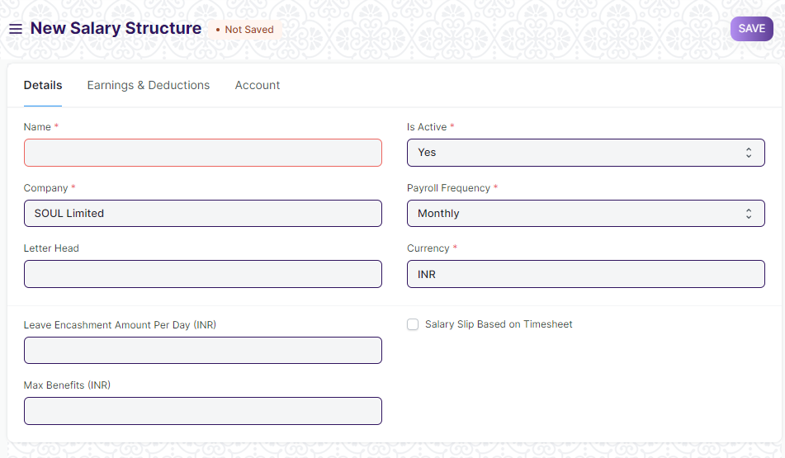

Figure 23 : Salary Structure Screen

**Field List**

The following table describes the UI fields present in this screen :

|  |  |  |  |  |  |  |
| --- | --- | --- | --- | --- | --- | --- |
| **ID** | **Label** | **Type** | **Mandatory** | **Validations/Action** | **Remarks** | R = Rename  N= New  D= Delete |
| 1 | Company | Link | Yes |  |  |  |
| 2 | Letter Head | Link |  |  |  |  |
| 3 | Is Active | Dropdown |  | Options:   1. Yes 2. No |  |  |
| 4 | Is Default | Dropdown |  | Options:   1. Yes 2. No |  |  |
| 5 | Payroll Frequency | Dropdown |  | Options:   1. Monthly 2. Fortnightly 3. Bimonthly 4. Weekly 5. Daily |  |  |
| 6 | Currency | Link |  |  |  |  |
| 7 | Leave Encashment Amount Per Day | Currency |  |  |  |  |
| 8 | Max Benefits (Amount) | Currency |  |  |  |  |
| 9 | Salary Slip Based on Time sheet | Checkbox |  | If checked,the Salary Slip for this structure will be generated on the basis of Time sheet. |  |  |
| 10 | Salary Component | Link |  |  |  |  |
| 11 | Hour Rate | Currency |  |  |  |  |
| 12 | Earnings | Table |  |  | This table is described below. |  |
| 13 | Deductions | Table |  |  | This table is described below. |  |
| 14 | Conditions and Formula variable and example | HTML |  |  |  |  |
| 15 | Total Earning | Currency |  |  |  |  |
| 16 | Total Deduction | Currency |  |  |  |  |
| 17 | Net Pay | Currency |  |  |  |  |
| 18 | Mode of Payment | Link |  |  |  |  |
| 19 | Payment Account | Link |  |  |  |  |
| **Earnings** | | | | | | |
| **ID** | **Label** | **Type** | **Mandatory** | **Validation/ Action** | **Remarks** | **R = Rename**  **N= New**  **D= Delete** |
| 1 | Component | Link | Yes | Link to master screen Salary Component |  |  |
| 2 | Amount | Currency |  | This field will be auto-populated on the basis of Component selected. |  |  |
| 3 | Abbr |  |  | This field will be auto-populated on the basis of Component selected. |  |  |
| 4 | Statistical Component |  |  |  |  |  |
| 5 | Condition and Formula |  |  | This field will be auto-populated on the basis of Component selected. |  |  |
| 6 | Amount Based on formula |  |  | This field will be auto-populated on the basis of Component selected. |  |  |
| **Deductions** | | | | | | |
| **ID** | **Label** | **Type** | **Mandatory** | **Validation/ Action** | **Remarks** | **R = Rename**  **N= New**  **D= Delete** |
| 1 | Component | Link | Yes | Link to master screen Salary Component |  |  |
| 2 | Amount | Currency |  | This field will be auto-populated on the basis of Component selected. |  |  |
| 3 | Abbr |  |  | This field will be auto-populated on the basis of Component selected. |  |  |
| 4 | Statistical Component |  |  |  |  |  |
| 5 | Condition and Formula |  |  | This field will be auto-populated on the basis of Component selected. |  |  |
| 6 | Amount Based on formula |  |  | This field will be auto-populated on the basis of Component selected. |  |  |

**User: Roles & Permission**

The following table describes the users and their roles and permissions for the screens :

|  |  |  |  |  |  |  |  |  |  |
| --- | --- | --- | --- | --- | --- | --- | --- | --- | --- |
| **ID** | **Role** | **Select** | **Read** | **Write** | **Create** | **Delete** | **Submit** | **Cancel** | **Amend** |
| 1 | HR Admin/Director Admin | Yes | Yes | Yes | Yes | Yes | Yes | Yes | Yes |
| 2 | HR Manager | No | Yes | Yes | Yes | Yes | Yes | Yes | Yes |
| 3 | HR Assistant | No | Yes | No | No | No | No | No | No |
| 4 | Employee | No | No | No | No | No | No | No | No |

**Transactional Screen**

### Salary Structure Assignment

**General Description**

The Following table describe overall information about this screen:

|  |  |  |
| --- | --- | --- |
| **Description** | | 1. Salary Structure Assignment form allows you to assign a particular Salary Structure to the employee. 2. User can create multiple Salary Structure Assignments for the same Employee for different periods. |
| **Navigation** | Home>HRMS>Salary>Salary Structure Assignment | |
| **Pre-requisites** | The system should have records in the following screen:   1. Employee 2. Salary Component 3. Salary Structure | |
| **Existing Screen Name** | Salary Structure Assignment | |
| **New Screen Name** | No change | |

**Screenshot**

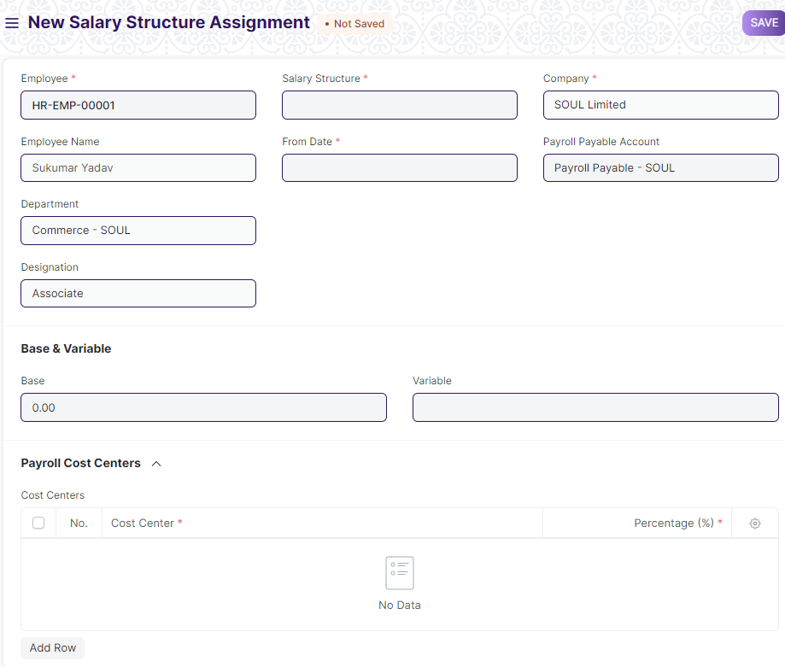

Figure 23 : Salary Structure Assignment Screen

**Field List**

The following table describes the UI fields present in this screen :

|  |  |  |  |  |  |  |
| --- | --- | --- | --- | --- | --- | --- |
| **ID** | **Label** | **Type** | **Mandatory** | **Validation/ Action** | **Remarks** | **R = Rename**  **N= New**  **D= Delete** |
| 1 | Employee | Link | Yes | Link to master screen Employee |  |  |
| 2 | Employee Name | Link |  | Employee name will be auto-populated on the basis of Employee Id Selected. |  |  |
| 3 | Department | Link |  | Department will be auto-populated on the basis of Employee Id Selected. |  |  |
| 4 | Employment Type | Link |  | Employment type will be auto-populated on the basis of Employee Id. |  |  |
| 5 | Designation | Link |  | Designation will be auto-populated on the basis of Employee Id. |  |  |
| 6 | Grade | Link |  | Grade will be auto-populated on the basis of Employee Id. |  |  |
| 7 | Salary Structure | Link | Yes | Link to the master screen Salary Structure |  |  |
| 8 | From Date | Link | Yes |  |  |  |
| 9 | Income Tax Slab | Link |  |  |  |  |
| 10 | Company | Link |  | Company field will be auto-populated on the basis of setting. |  |  |
| 11 | Payroll Payable Account | Link |  |  |  |  |
| 12 | Currency | Link |  |  |  |  |
| 13 | Base | Currency |  |  |  |  |
| 14 | Variable | Currency |  |  |  |  |
| 15 | Taxable Earnings Till Date | Currency |  |  |  |  |
| 16 | Tax Deducted Till Date | Currency |  |  |  |  |
| 17 | Cost Centers | Table |  |  |  |  |
| **Cost Center** | | | | | | |
| **ID** | **Label** | **Type** | **Mandatory** | **Validation/ Action** | **Remarks** | **R = Rename**  **N= New**  **D= Delete** |
| 1 | Cost Center | Link |  | Link to screen Cost Center |  |  |
| 2 | Percentage(%) | Number |  |  |  |  |

**User: Roles & Permission**

The following table describes the users and their roles and permissions for the screens :

|  |  |  |  |  |  |  |  |  |  |
| --- | --- | --- | --- | --- | --- | --- | --- | --- | --- |
| **ID** | **Role** | **Select** | **Read** | **Write** | **Create** | **Delete** | **Submit** | **Cancel** | **Amend** |
| 1 | HR Admin/Director Admin | Yes | Yes | Yes | Yes | Yes | Yes | Yes | Yes |
| 2 | HR Manager | No | Yes | Yes | Yes | Yes | Yes | Yes | No |
| 3 | HR Assistant | No | Yes | No | No | No | No | No | No |
| 4 | Employee | No | Yes | No | No | No | No | No | No |